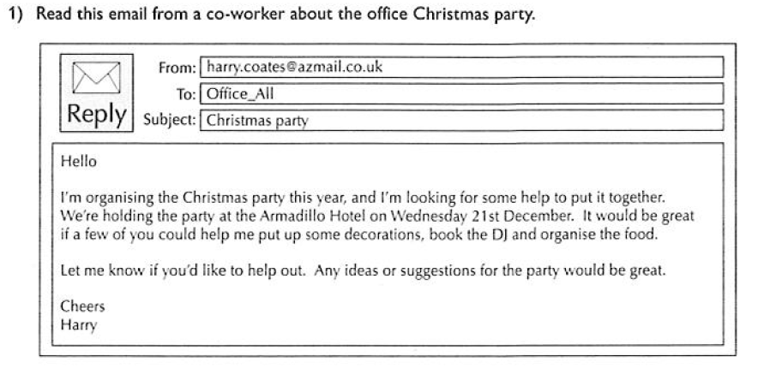

Write a short reply which:
- Tells Harry that you would like to help organise the party
- Says how you would like to help out
- Gives any suggestions you have for the party
Write your answer on a separate piece of paper. Make sure your spelling, punctuation and grammar are correct.

